**Project 3 Outline**

**Group 2**

Dalton Driver, Drew Johnson, Saniya Kulkarni, Sarah Nystrom, Martin Rybicki

**Project Topic**

Our group will visualize crime statistics reported from Austin Police Department (APD).

**Project Repository**

<https://github.com/snystrom-github/Group2_Project3.git>

**Data Source**

This data source has 2.5M records which meets the requirement of having a minimum of 100 records.

[Crime Reports | Open Data | City of Austin Texas](https://data.austintexas.gov/Public-Safety/Crime-Reports/fdj4-gpfu/about_data)

**Potential Visualizations**

1. Cluster markers/polys/popups (image 1 as example)
2. Heat map/choropleth (image 2 as example)
3. Markers (image 3 as example)

**Potential User-Driven Interactions**

1. Toggle
2. Dropdown

Image 1

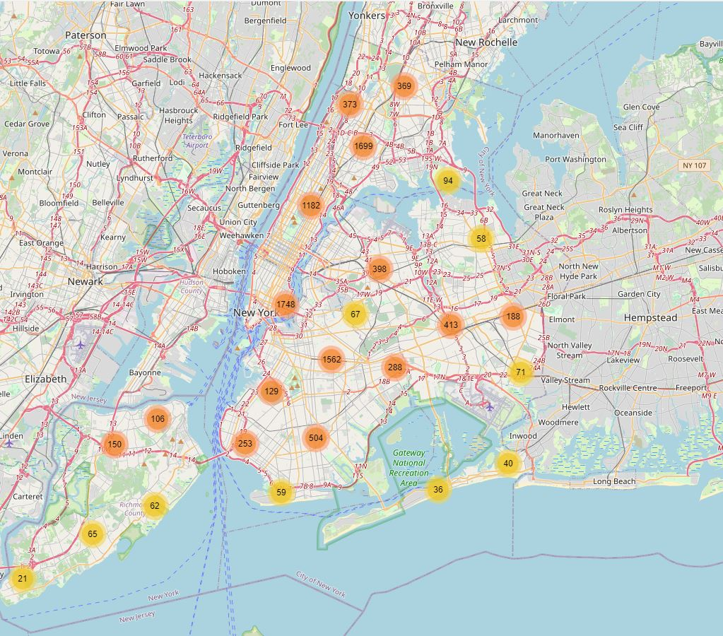

Image 2

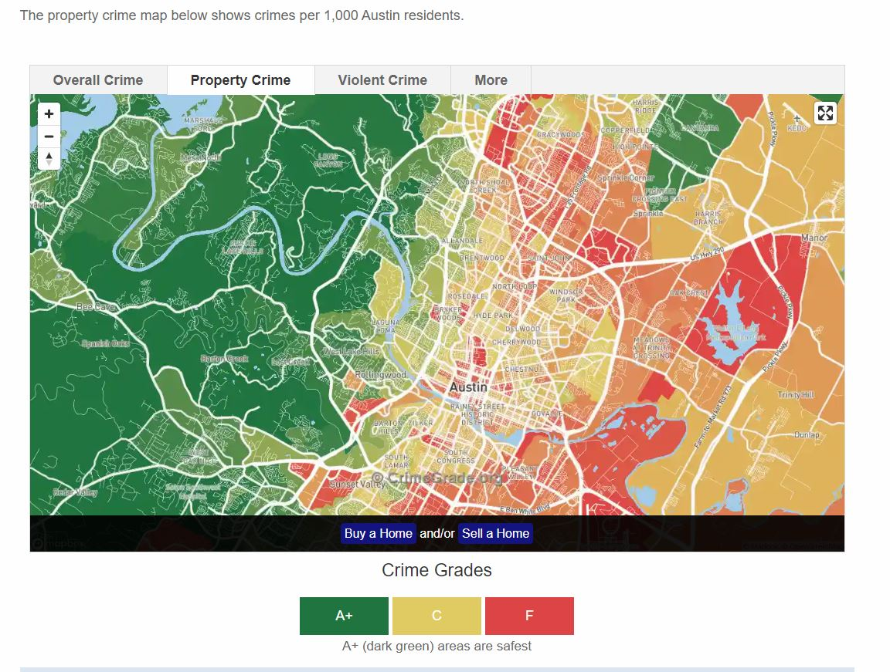

Image 3

